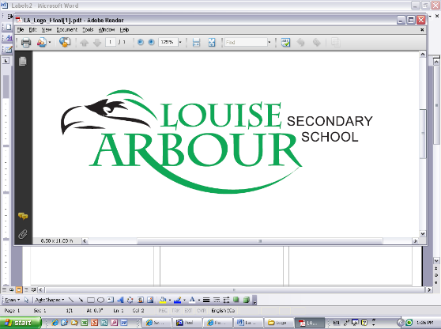SPH3U0- **PhotoVoltaic Panel Collector Summative Task**

**Dates:** ***Thursday Jan 16 - Monday January 20***

**Background**

The need to replace our dependence on fossil fuels as an energy source is a pressing problem that Canada currently faces. One alternative “green” energy source to generate electrical energy is solar-power. As of 2015, the electrical energy in Canada generated by solar was 2,130 MW which represents a 2,300% increase since 2005. Although small compared to other sources, solar energy is becoming more popular as the cost of PV panels continues to decrease. Currently, over 98% of Canada’s solar generation capacity is located in Ontario. In this task, you will investigate the potential and challenges of using solar power to generate electrical energy by designing and building a PV panel collector.

[1] National Energy Board: https://www.neb-one.gc.ca/nrg/sttstc/lctrct/rprt/2017cndrnwblpwr/2017cndrnwblpwr-eng.pdf

**Task: To design, build and test a Photo-Voltaic (PV) panel collector.**

**Design and Construction of a PV Collector**

The collector will consist of ***two small PV panels*** and a ***reflector supporting structure***. The PV panels will be supplied by your teacher. The reflector supporting structure will be built by you to hold the panels and to enhance their operation by collecting and reflecting light.

The PV panels will be connected in series and in parallel so that you can test and compare their performance quantitatively. Your collector structure may include reflector panels to focus the light on the solar cells.

The collector structure should fit within a cube no more than **30x30x30 cm** in volume.

**Testing of Your PV Collector**

Once your reflector supporting structure is constructed you will test the PV panels in standardized light conditions produced by light bulbs of different brightness. One set of measurements will be made with the PV panels connected in parallel and another set of measurements made with the PV panels connected in series.

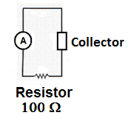You will evaluate the power output of the collector by connecting the panels to a resistor and measuring the current passing through the resistor when the collector is operating. You will compare the power output of the collector to the power available using the panels alone to determine the efficiency increase of your collector system.

Testing Circuit:

**Analysis of Collector Performance:**

1. Test the power output of the PV panels ***on their own when they are connected in series*** at three luminance levels and determine the ***electrical power output of the PV panels at each bulb brightness***. Electrical power output (Pel) can be determined by measuring the current (I) passing through the resistor and using the following formula: (Observation Table 1)

**Pel= I2R.**

1. Add your ***collector system*** to the PV panels connected ***in s*eries** and determine the ***electrical power output of your collector system at each bulb brightness*** as in step 1. (Observation Table 2)
2. Repeat the testing of the ***collector system*** with the PV panels connected ***in parallel*** and determine ***the electrical power output of your collector system at each brightness level*** as in step 1 and 2. (Observation Table 3)
3. Calculate the efficiency of your solar panel collector system at each luminance level, from the data in observation tables 2 and 3, by comparing the power generated by your collector to input electrical power of the light bulbs provided.
4. Plot a graph of **power output** versus **input electrical power** for the series and parallel configurations.
5. Plot a graph of **efficiency** versus **input electrical power** for the series and parallel configurations.

**Solar Collector Design Report: *(May be prepared outside of class time)***

Prepare a brief report (2 pages maximum in length) describing your collector design. Include the following:

• Hypothesis:

1. ***A prediction, with justification, regarding the impact of your collector design on the power output of the solar panels.***
2. ***A prediction, with justification, about whether the panels will perform better when connected in***

***series or in parallel.***

• An overview of your collector design features

• Materials list

• A photograph and accurate diagram (labeled, scale or dimensions indicated, side/head-on views) • Discussion of the design features considered and any major challenges overcome

during the construction phase

**• REFERENCE LIST in APA Format: List all books, websites, videos consulted.**

**Performance Investigation Report: (*To be prepared in-class*)**

Write up formal lab report for your collector testing and analysis. Your report should include:

• purpose

• materials

• procedure written in past, passive tense

• labeled diagram of the collector testing set-up

• observation tables

• analysis(including graphs and sample calculations of power output and collector efficiency)

• discussion

• conclusion

• error analysis (discussion of at least TWO sources of error)

***Your discussion should address the following points:***

1. Discuss the impact of the collector system on the output power generated by comparing the data in tables 1 and 2. What physical characteristics might account for the various power efficiencies achieved? Was your hypothesis ***(part a)*** supported?
2. Discuss how the power produced by the generator varies as the brightness level changes.

Refer to the graphs of power versus luminance level to support your discussion.

1. Discuss in general how the electrical power available from the light source compares to the power

generated by the collector. Refer to your graph of power efficiency to support your discussion.

1. Refer to your graphs to compare the performance of series and parallel PV panel configurations . In what ways the performance similar and in what ways was it different? Was your hypothesis ***(part b)*** supported?

**Evaluation Overview:**  **Total: 100 marks**

**Collector Design and Construction: 20 marks**

The supporting reflector will be evaluated for design thoughtfulness of design and quality **Collector Operational on First In-Class Summative Date: 10 marks**

**Collector Operation:** Demonstrate a working collector for the teacher**. 10 marks**

Demonstrate the operation of your working collector for the teacher.

**Collector Design Report** **20 marks**

**Collector Testing Report:** **40 marks**